Cloud Automation & CI/CD Assignment
Assignment Title: Automating Workflows with GitHub Actions
Level: Internship
Course: Cloud Operations
Duration: 2 week

Task 1: Installing and Configuring GitHub Actions
Screenshot of GitHub Actions dashboard
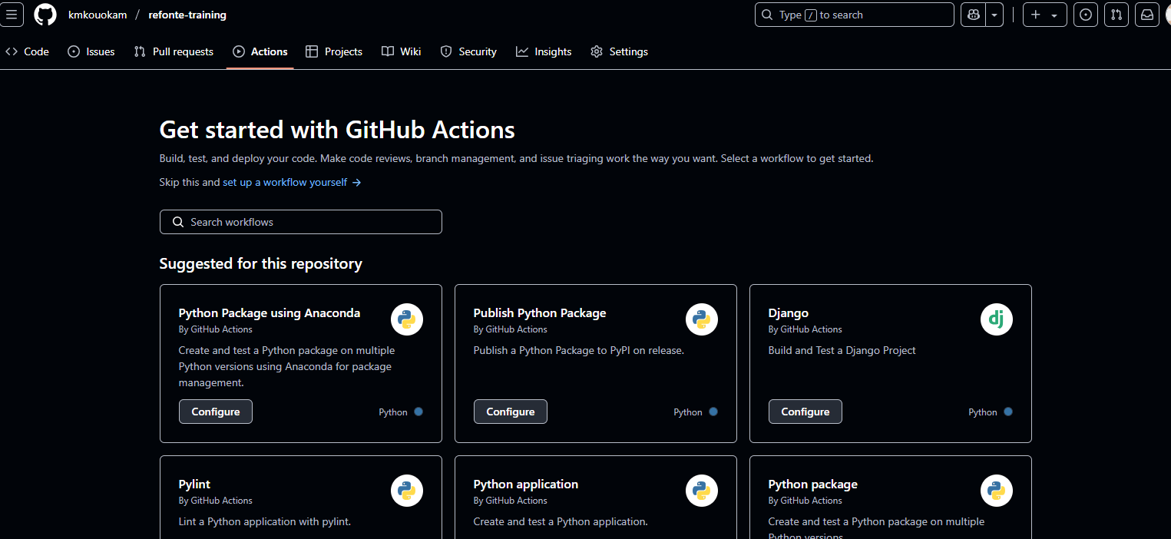
List of third-party actions installed and their roles
I install docker to build images
Overview of repository permissions for workflows
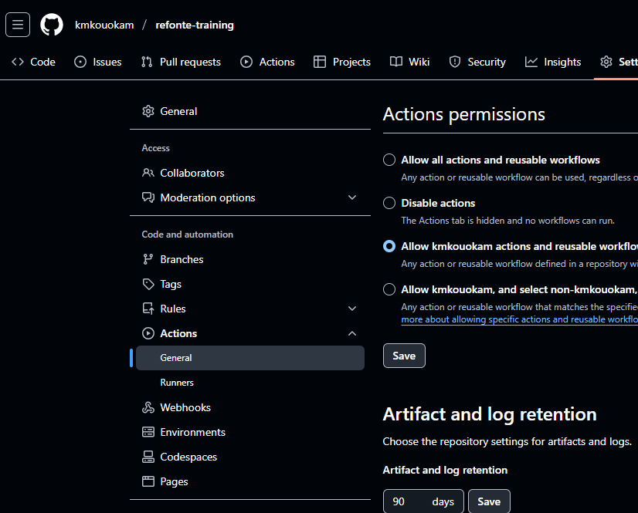
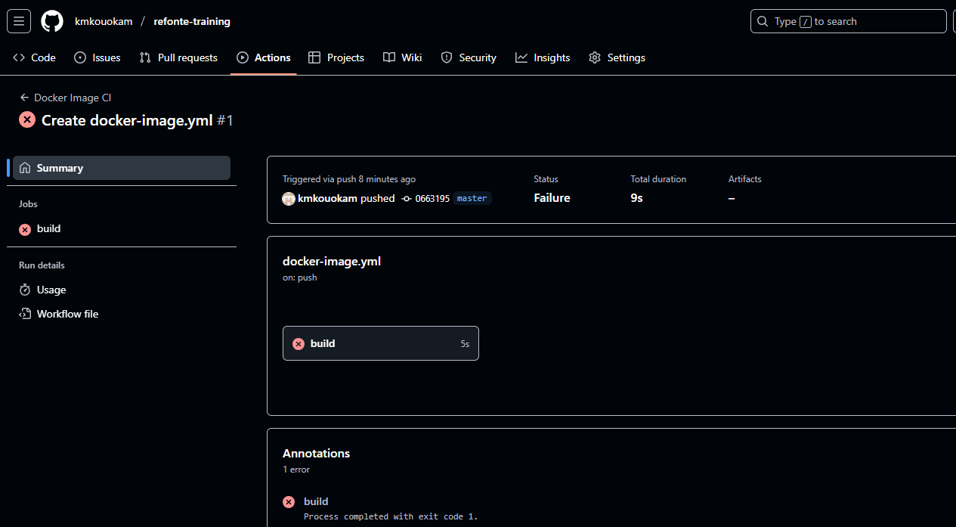
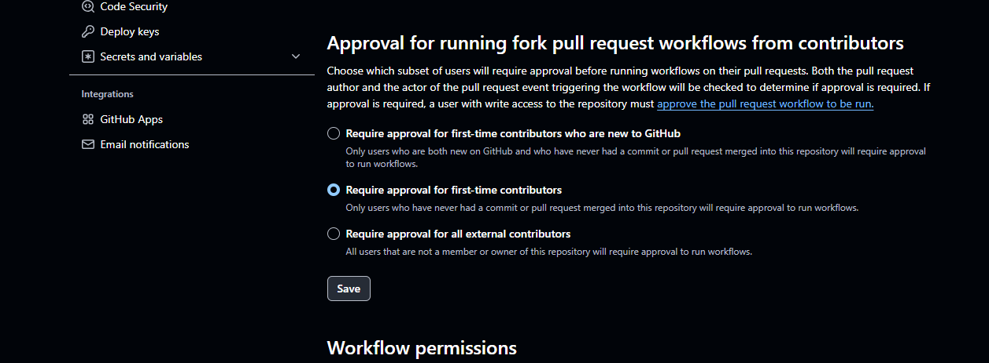
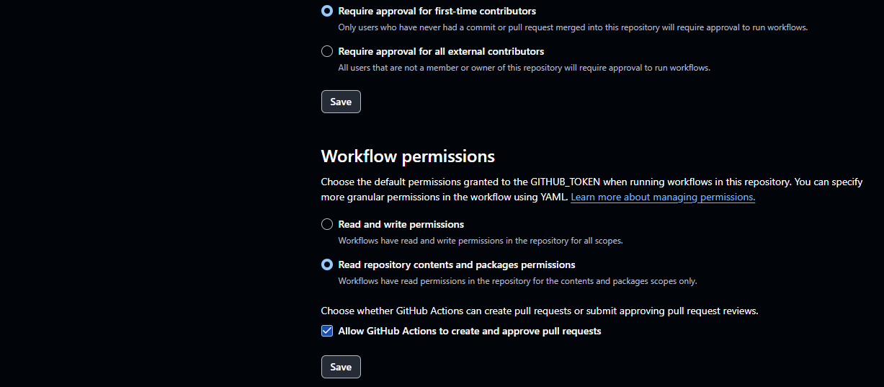

Task 2: Creating a GitHub Actions CI Pipeline
- Link Repository and Set up Source Control Integration (SCM):

- Do ssh key exchange from the local computer to the GitHub account by setting the ssh key
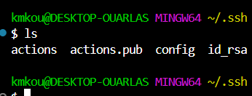
- Cat the ssh_pub key and create an ssh and GPG key record in GitHub account setting
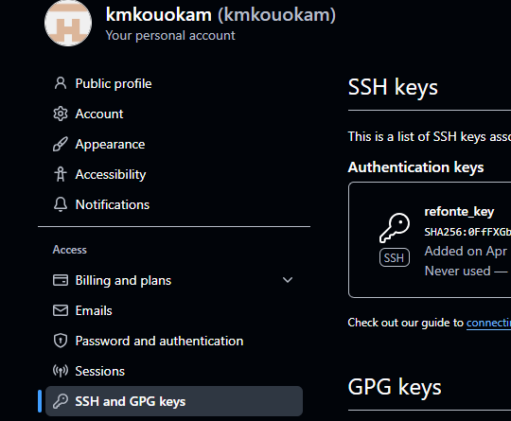
In order to make sure our repositories use the ssh key we created let run the below commands

- - Let export the key: export GIT_SSH_COMMAND="ssh -i ~/.ssh/actions"
- git config core.sshCommand "ssh -i ~/.ssh/actions -F /dev/null"
- let set the global configuration with the GitHub account name and email address for login purpose

- Setting up a repository in GitHub and create secrets and variable records for aws credentials and S3 bucket
Create IAM user with Credentials
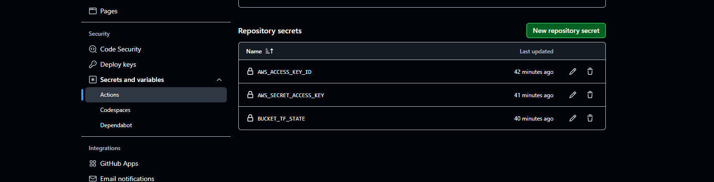

  - Build a CI Pipeline:
name: Node.js CI

on:
push:
branches: ["carine"]
pull_request:
branches: ["carine"]

permissions:
actions: read
contents: read
security-events: write

jobs:
build-and-test:
runs-on: ubuntu-latest

steps:
- name: Checkout code
uses: actions/checkout@v3

# - name: Initialize CodeQL
# uses: github/codeql-action/init@v3
# with:
# languages: javascript

- name: Set up Node.js
uses: actions/setup-node@v3
with:
node-version: '18' # Use the latest LTS version
# cache: 'npm'

- name: install dependencies
run: |
npm install

- name: run build
run: |
npm run build || true

- name: run tests (no test implemented)
run: echo "no test implemented yet"

- name: run eslint #This will catch bad coding practices and some security issues
run: |
npm install eslint --save-dev
npx eslint . --ext .js,.ts

- name: run audit for vulnerabilities
run: |
# npm audit --audit-level=high || true
npm audit fix --force || true

- name: run nodejsScan (with folder exclusion)
run: |
pip install nodejsscan
mkdir -p nodejsscan-reports
find . -type f -name "*.js" \
-not -path "./node_modules/*" \
-not -path "./dist/*" \
-not -path "./coverage/*" \
-not -path "./.build/*" \
-not -path "./.next/*" \
> files_to_scan.txt
nodejsscan -f $(cat files_to_scan.txt) -o nodejsscan-reports/report.json

- name: Notify Slack #Store your webhook URL as a secret (SLACK_WEBHOOK) in your repo settings @https://api.slack.com/messaging/webhooks
if: failure() || success()
uses: rtCamp/action-slack-notify@v2
env:
SLACK_WEBHOOK: ${{ secrets.SLACK_WEBHOOK }}
SLACK_MESSAGE: "Build ${{ job.status }} for ${{ github.repository }} on ${{ github.ref }}"
#Webhook URL for Slack notifications: https://join.slack.com/t/internship-rma1183/shared_invite/zt-35s0h7vip-5J8D~M_3QpLfp9YqVwMrPA
SLACK_COLOR: ${{ job.status == 'success' && 'good' || 'danger' }}
SLACK_CHANNEL: '#all-internship'
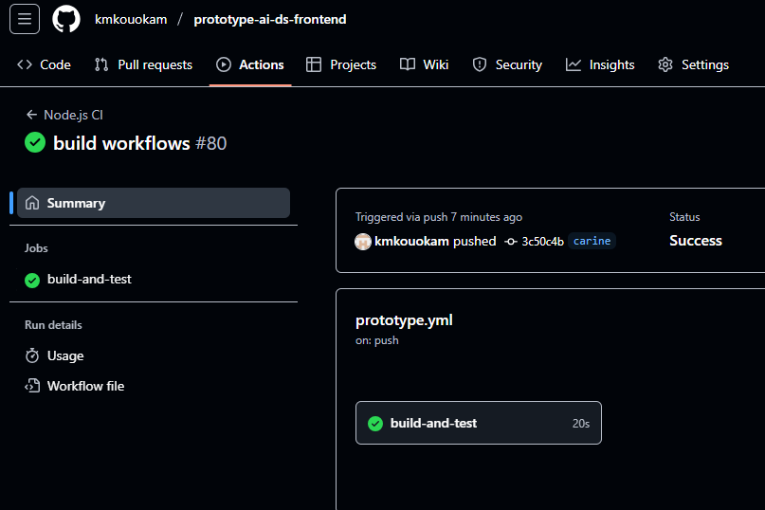

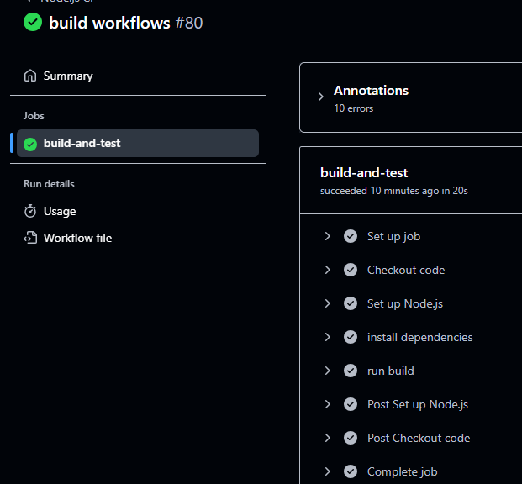
Review the workflow logs for build results and potential issues.
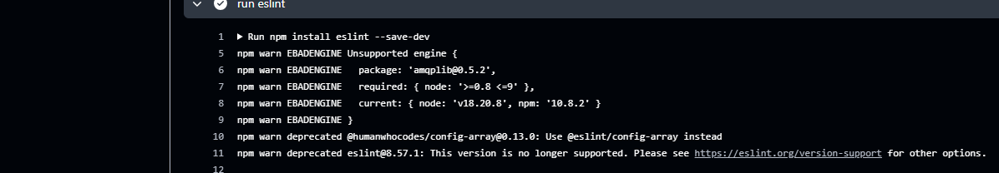
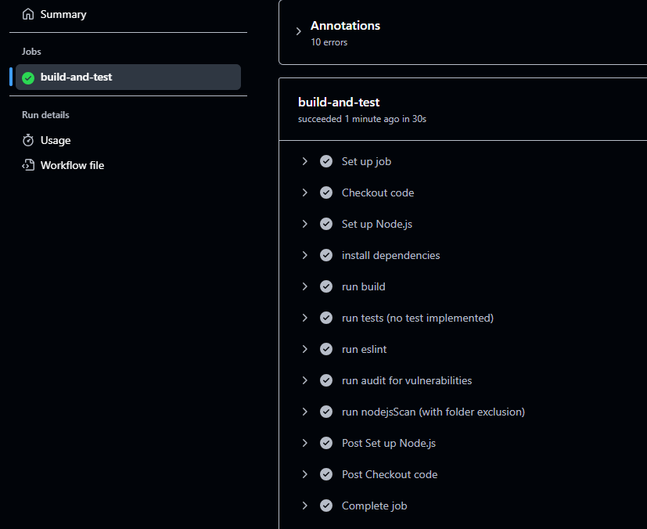

Slack notifications set up
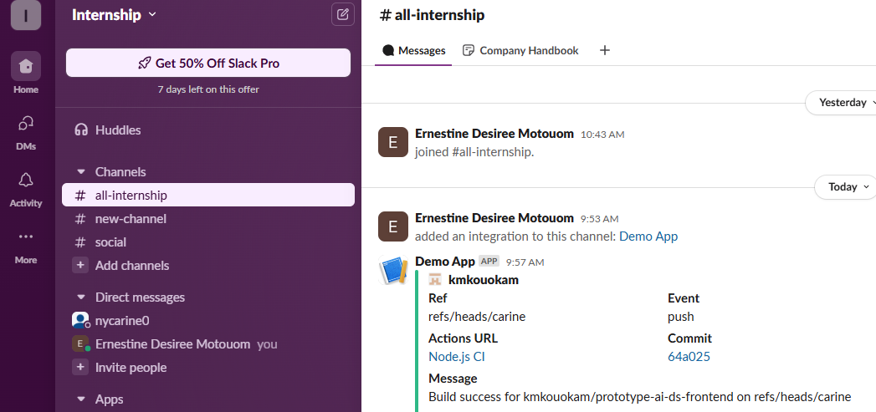

GitHub Secrets (Repo Settings → Secrets → Actions)
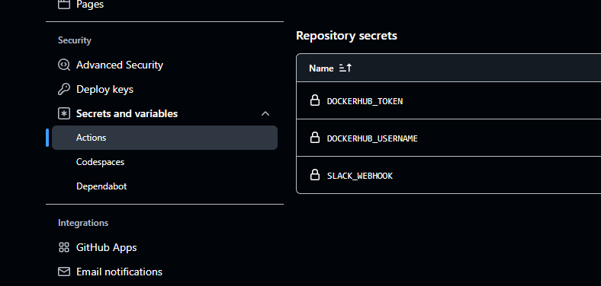

Task 3: Automating Builds
- Build And archive the artifact
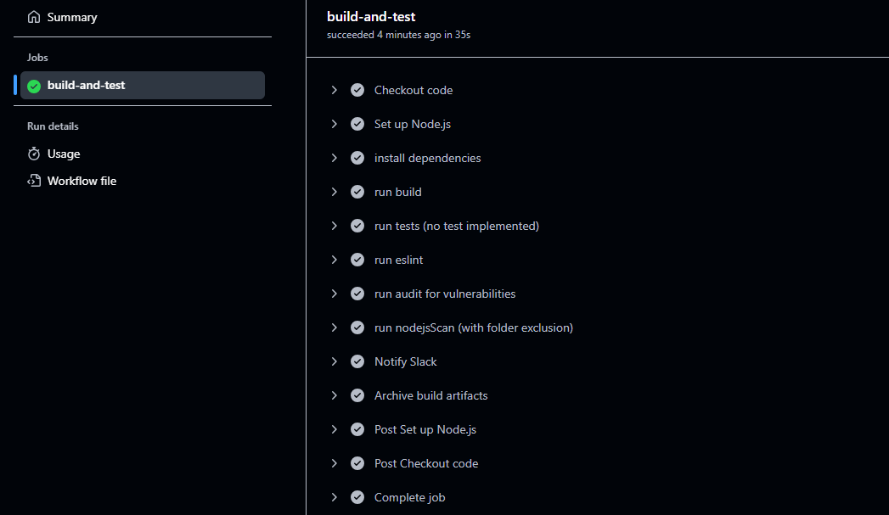

Build and push to s3
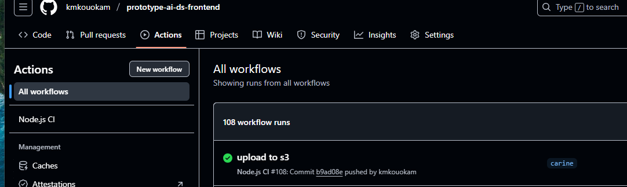
- Automate Testing:
  - Integrate unit testing with actions like actions/setup-python or actions/setup-java.
  - Check the test results and handle any failures or errors.

Task 4: Enhancing CI/CD with GitHub Actions Features
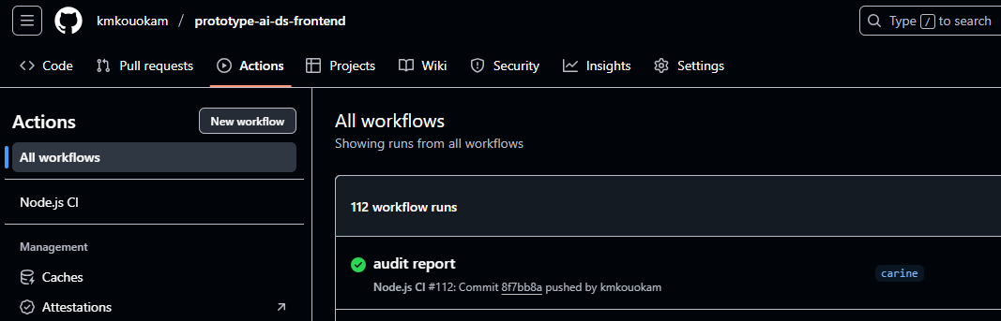
- Improve workflow visualization with GitHub Actions’ UI.
name: ⚙️ Node.js CI Workflow

on:
push:
branches: ["carine"]
pull_request:
branches: ["carine"]

permissions:
actions: read
contents: read
security-events: write

jobs:
build-and-deploy:
name: 🚀 Build, Scan & Deploy
runs-on: ubuntu-latest

steps:
- name: 🔄 Checkout Repository
uses: actions/checkout@v3

- name: ⚙️ Setup Node.js
uses: actions/setup-node@v3
with:
node-version: '18'

- name: 📦 Install Dependencies
run: npm install

- name: 🛠️ Build Project
run: npm run build || true

- name: 🧱 Ensure dist Directory Exists
run: |
if [ ! -d "dist" ]; then
mkdir dist
echo "<html><body><h1>Dummy Build</h1></body></html>" > dist/index.html
fi

- name: 🧹 Lint Code (ESLint)
run: |
npm install eslint --save-dev || true
npx eslint . --ext .js,.ts

- name: 🛡️ Fix Vulnerabilities (npm audit fix)
run: npm audit fix --force || true

- name: 📊 Generate Audit Report (JSON)
run: npm audit --json > audit-report.json || true

- name: 📁 Upload Audit Report
uses: actions/upload-artifact@v4
with:
name: npm-audit-report
path: audit-report.json

- name: 🔍 Run Node.jsScan (Static Analysis)
run: |
pip install nodejsscan
mkdir -p nodejsscan-reports
find . -type f -name "*.js" \
-not -path "./node_modules/*" \
-not -path "./dist/*" \
-not -path "./coverage/*" \
-not -path "./.build/*" \
-not -path "./.next/*" > files_to_scan.txt
nodejsscan -f $(cat files_to_scan.txt) -o nodejsscan-reports/report.json

- name: 🧪 (Optional) Run Unit Tests
if: false # change to `true` or remove to enable
run: npm test

- name: 📦 Archive Build Artifacts
if: success()
uses: actions/upload-artifact@v4
with:
name: build-artifacts
path: dist/

- name: ☁️ Upload to S3 (Production)
uses: jakejarvis/s3-sync-action@master
with:
args: --delete
env:
AWS_S3_BUCKET: refontebucket
AWS_ACCESS_KEY_ID: ${{ secrets.AWS_ACCESS_KEY_ID }}
AWS_SECRET_ACCESS_KEY: ${{ secrets.AWS_SECRET_ACCESS_KEY }}
AWS_REGION: us-east-1
SOURCE_DIR: dist

- name: 📢 Slack Notification
if: always()
uses: rtCamp/action-slack-notify@v2
env:
SLACK_WEBHOOK: ${{ secrets.SLACK_WEBHOOK }}
SLACK_MESSAGE: "Build *${{ job.status }}* for *${{ github.repository }}* on `${{ github.ref }}`"
SLACK_COLOR: ${{ job.status == 'success' && 'good' || 'danger' }}
SLACK_CHANNEL: '#all-internship'
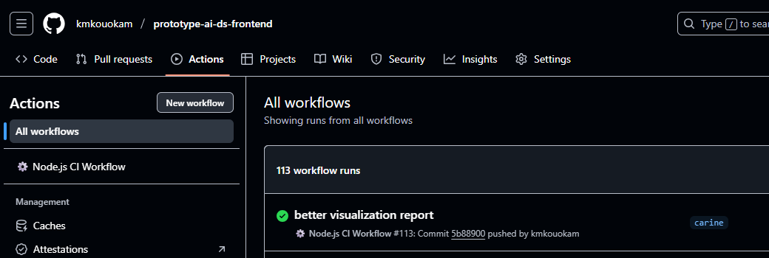

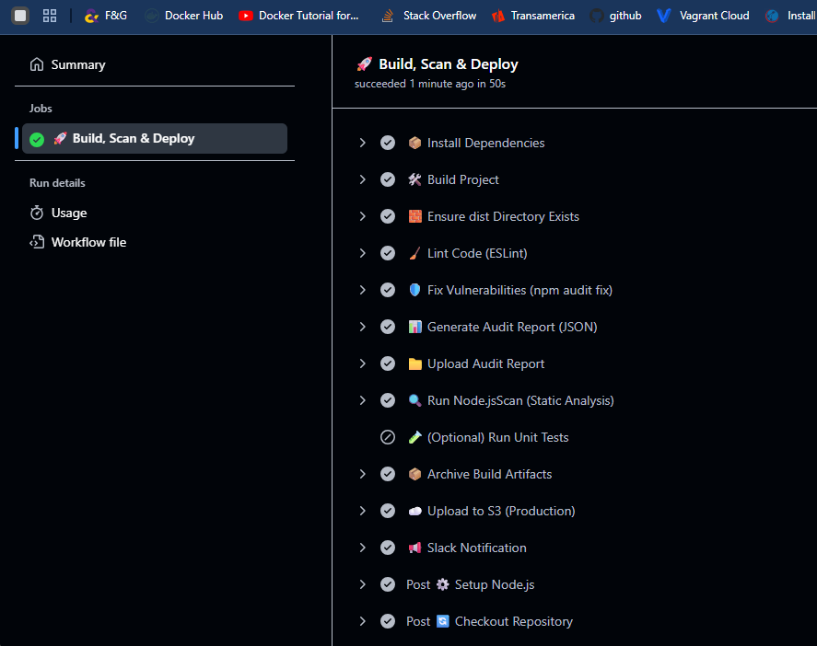
- Set Up Post-Deployment Actions:
  - Automate deployment to staging or production using GitHub Actions.
name: ⚙️ Node.js CI/CD Workflow

on:
push:
branches:
- staging
- main
pull_request:
branches:
- staging
- main

permissions:
actions: read
contents: read
security-events: write

jobs:
build-and-deploy:
name: 🚀 Build, Scan & Deploy
runs-on: ubuntu-latest

steps:
- name: 🔄 Checkout Repository
uses: actions/checkout@v3

- name: ⚙️ Setup Node.js
uses: actions/setup-node@v3
with:
node-version: '18'

- name: 📆 Install Dependencies
run: npm install

- name: 💠 Build Project
run: npm run build || true

- name: 🧱 Ensure dist Directory Exists
run: |
if [ ! -d "dist" ]; then
mkdir dist
echo "<html><body><h1>Dummy Build</h1></body></html>" > dist/index.html
fi

- name: 🧹 Lint Code (ESLint)
run: |
npm install eslint --save-dev || true
npx eslint . --ext .js,.ts

- name: 🛡️ Fix Vulnerabilities (npm audit fix)
run: npm audit fix --force || true

- name: 📊 Generate Audit Report (JSON)
run: npm audit --json > audit-report.json || true

- name: 📁 Upload Audit Report
uses: actions/upload-artifact@v4
with:
name: npm-audit-report
path: audit-report.json

- name: 🔍 Run Node.jsScan (Static Analysis)
run: |
pip install nodejsscan
mkdir -p nodejsscan-reports
find . -type f -name "*.js" \
-not -path "./node_modules/*" \
-not -path "./dist/*" \
-not -path "./coverage/*" \
-not -path "./.build/*" \
-not -path "./.next/*" > files_to_scan.txt
nodejsscan -f $(cat files_to_scan.txt) -o nodejsscan-reports/report.json

- name: 🧪 (Optional) Run Unit Tests
if: false # change to `true` or remove to enable
run: npm test

- name: 📦 Archive Build Artifacts
if: success()
uses: actions/upload-artifact@v4
with:
name: build-artifacts
path: dist/

- name: ☁️ Upload to S3 (Env-specific)
uses: jakejarvis/s3-sync-action@master
with:
args: --delete
env:
AWS_S3_BUCKET: ${{ github.ref == 'refs/heads/main' && secrets.AWS_S3_BUCKET_PROD || secrets.AWS_S3_BUCKET_STAGING }}
AWS_ACCESS_KEY_ID: ${{ secrets.AWS_ACCESS_KEY_ID }}
AWS_SECRET_ACCESS_KEY: ${{ secrets.AWS_SECRET_ACCESS_KEY }}
AWS_REGION: us-east-1
SOURCE_DIR: dist

- name: 📢 Slack Notification
if: always()
uses: rtCamp/action-slack-notify@v2
env:
SLACK_WEBHOOK: ${{ secrets.SLACK_WEBHOOK }}
SLACK_MESSAGE: "Build *${{ job.status }}* for *${{ github.repository }}* on `${{ github.ref }}`"
SLACK_COLOR: ${{ job.status == 'success' && 'good' || 'danger' }}
SLACK_CHANNEL: '#all-internship'

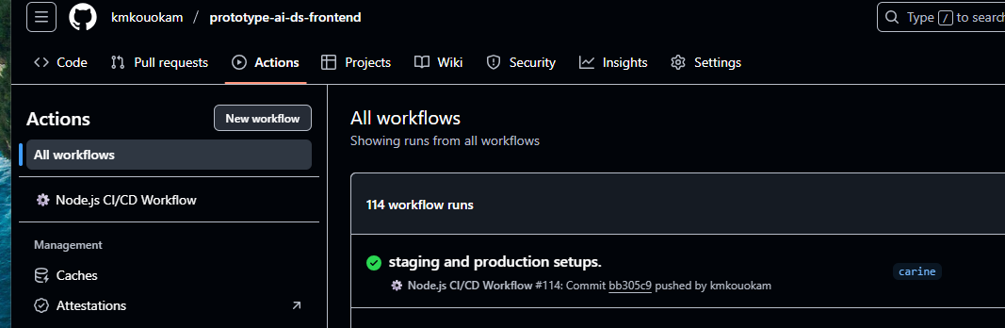
  - Configure post-deployment notifications or reports.
- name: 📰 Post-Deployment Notification
run: |
echo "Deployment completed to ${{ github.ref == 'refs/heads/main' && 'Production' || 'Staging' }} environment." > deployment-report.txt
echo "Date: $(date)" >> deployment-report.txt
echo "Commit: $GITHUB_SHA" >> deployment-report.txt
echo "Actor: $GITHUB_ACTOR" >> deployment-report.txt

- name: 📁 Upload Deployment Report
uses: actions/upload-artifact@v4
with:
name: deployment-report
path: deployment-report.txt
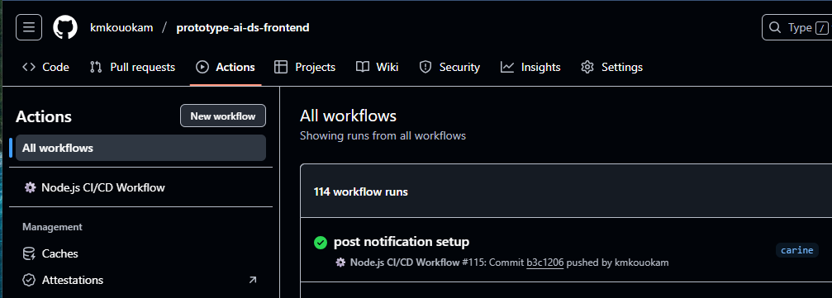

Task 5: Troubleshooting and Performance Optimization
This workflow does:
• Node.js dependencies caching
• Matrix builds for Node.js versions
• Reduced redundant installs
• Parallel execution
• Deployment only on production branch (main)
• Post-deployment Slack notification
• Artifact and audit uploads preserved
name: ⚙️ Node.js CI Workflow

on:
push:
branches: [main, carine]
pull_request:

permissions:
actions: read
contents: read
security-events: write

jobs:
test-lint-build:
name: 🔧 Test & Build (Node ${{ matrix.node-version }})
runs-on: ubuntu-latest
strategy:
matrix:
node-version: [16, 18] # Matrix for speed and compatibility testing
steps:
- name: 🔄 Checkout Repository
uses: actions/checkout@v3

- name: ⚙️ Setup Node.js
uses: actions/setup-node@v3
with:
node-version: ${{ matrix.node-version }}
cache: 'npm'

- name: 📦 Install Dependencies
run: npm ci

- name: 🧹 Lint Code
run: |
npm install eslint --save-dev || true
npx eslint . --ext .js,.ts || echo "⚠️ ESLint warnings present."

- name: 🧪 Run Unit Tests (optional)
if: false # toggle to true or remove to enable
run: npm test

- name: 🛠️ Build Project
run: |
npm run build || echo "⚠️ Build failed. Creating dummy dist..."
if [ ! -d "dist" ]; then
mkdir dist
echo "<html><body><h1>Dummy Build</h1></body></html>" > dist/index.html
fi

- name: 📦 Upload Build Artifacts
if: success()
uses: actions/upload-artifact@v4
with:
name: build-artifacts-node-${{ matrix.node-version }}
path: dist/

security-audit:
name: 🔒 Audit & Static Scan
runs-on: ubuntu-latest
needs: test-lint-build

steps:
- name: 🔄 Checkout Repository
uses: actions/checkout@v3

- name: ⚙️ Setup Node.js
uses: actions/setup-node@v3
with:
node-version: 18
cache: 'npm'

- name: 📦 Install Dependencies
run: npm ci

- name: 🛡️ Fix Vulnerabilities (npm audit fix)
run: npm audit fix --force || true

- name: 📊 Generate Audit Report
run: npm audit --json > audit-report.json || true

- name: 📁 Upload Audit Report
uses: actions/upload-artifact@v4
with:
name: npm-audit-report
path: audit-report.json

- name: 🔍 Run Node.jsScan (Static Analysis)
run: |
pip install nodejsscan
mkdir -p nodejsscan-reports
find . -type f -name "*.js" \
-not -path "./node_modules/*" \
-not -path "./dist/*" \
-not -path "./coverage/*" \
> files_to_scan.txt
nodejsscan -f $(cat files_to_scan.txt) -o nodejsscan-reports/report.json

- name: 📁 Upload nodejsscan Report
uses: actions/upload-artifact@v4
with:
name: nodejsscan-report
path: nodejsscan-reports/report.json

deploy:
name: 🚀 Deploy to S3 (Production)
runs-on: ubuntu-latest
needs: [test-lint-build, security-audit]
if: github.ref == 'refs/heads/main'

steps:
- name: ⬇️ Download Artifacts
uses: actions/download-artifact@v4
with:
name: build-artifacts-node-18
path: dist/

- name: ☁️ Upload to S3
uses: jakejarvis/s3-sync-action@master
with:
args: --delete
env:
AWS_S3_BUCKET: refontebucket
AWS_ACCESS_KEY_ID: ${{ secrets.AWS_ACCESS_KEY_ID }}
AWS_SECRET_ACCESS_KEY: ${{ secrets.AWS_SECRET_ACCESS_KEY }}
AWS_REGION: us-east-1
SOURCE_DIR: dist

- name: 📝 Deployment Report
run: |
echo "Deployment completed on $(date)" > deployment-report.txt
echo "Branch: ${{ github.ref }}" >> deployment-report.txt
echo "Commit: ${{ github.sha }}" >> deployment-report.txt

- name: 📁 Upload Deployment Report
uses: actions/upload-artifact@v4
with:
name: deployment-report
path: deployment-report.txt

- name: 📢 Slack Notification
if: always()
uses: rtCamp/action-slack-notify@v2
env:
SLACK_WEBHOOK: ${{ secrets.SLACK_WEBHOOK }}
SLACK_MESSAGE: "🚀 Deployment *${{ job.status }}* for *${{ github.repository }}* on `${{ github.ref }}`"
SLACK_COLOR: ${{ job.status == 'success' && 'good' || 'danger' }}
SLACK_CHANNEL: '#all-internship'
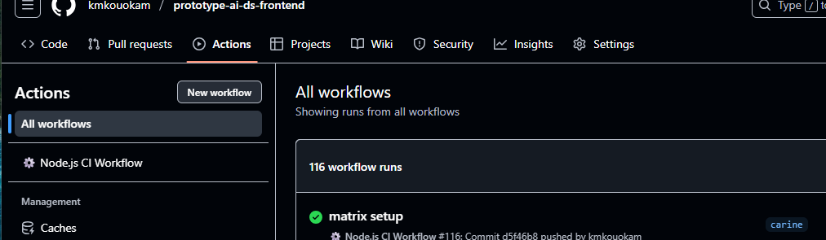
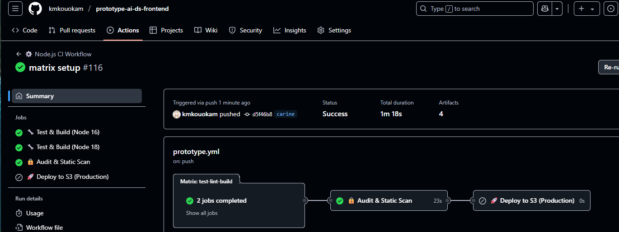

Workflow updated GitHub Actions workflow with events configured to support pushes to carine, staging, and production, while only triggering pull requests when targeting main.
This workflow support:
- Push-based CI/CD on carine, staging, production, and main
- Pull request validation only when merging into main
- Production deployment only when pushing to production
- Fast parallel builds via matrix
- Post-deployment reporting and Slack notification

name: ⚙️ Node.js CI Workflow

on:
push:
branches: [carine, staging, production, main]
pull_request:
branches: [main] # Only run PR checks if merging into main

permissions:
actions: read
contents: read
security-events: write

jobs:
test-lint-build:
name: 🔧 Test & Build (Node ${{ matrix.node-version }})
runs-on: ubuntu-latest
strategy:
matrix:
node-version: [16, 18] # Matrix for speed and compatibility testing
steps:
- name: 🔄 Checkout Repository
uses: actions/checkout@v3

- name: ⚙️ Setup Node.js
uses: actions/setup-node@v3
with:
node-version: ${{ matrix.node-version }}
cache: 'npm'

- name: 📦 Install Dependencies
run: npm ci

- name: 🧹 Lint Code
run: |
npm install eslint --save-dev || true
npx eslint . --ext .js,.ts || echo "⚠️ ESLint warnings present."

- name: 🧪 Run Unit Tests (optional)
if: false # toggle to true or remove to enable
run: npm test

- name: 🛠️ Build Project
run: |
npm run build || echo "⚠️ Build failed. Creating dummy dist..."
if [ ! -d "dist" ]; then
mkdir dist
echo "<html><body><h1>Dummy Build</h1></body></html>" > dist/index.html
fi

- name: 📦 Upload Build Artifacts
if: success()
uses: actions/upload-artifact@v4
with:
name: build-artifacts-node-${{ matrix.node-version }}
path: dist/

security-audit:
name: 🔒 Audit & Static Scan
runs-on: ubuntu-latest
needs: test-lint-build

steps:
- name: 🔄 Checkout Repository
uses: actions/checkout@v3

- name: ⚙️ Setup Node.js
uses: actions/setup-node@v3
with:
node-version: 18
cache: 'npm'

- name: 📦 Install Dependencies
run: npm ci

- name: 🛡️ Fix Vulnerabilities (npm audit fix)
run: npm audit fix --force || true

- name: 📊 Generate Audit Report
run: npm audit --json > audit-report.json || true

- name: 📁 Upload Audit Report
uses: actions/upload-artifact@v4
with:
name: npm-audit-report
path: audit-report.json

- name: 🔍 Run Node.jsScan (Static Analysis)
run: |
pip install nodejsscan
mkdir -p nodejsscan-reports
find . -type f -name "*.js" \
-not -path "./node_modules/*" \
-not -path "./dist/*" \
-not -path "./coverage/*" \
> files_to_scan.txt
nodejsscan -f $(cat files_to_scan.txt) -o nodejsscan-reports/report.json

- name: 📁 Upload nodejsscan Report
uses: actions/upload-artifact@v4
with:
name: nodejsscan-report
path: nodejsscan-reports/report.json

deploy:
name: 🚀 Deploy to S3 (Production)
runs-on: ubuntu-latest
needs: [test-lint-build, security-audit]
if: github.ref == 'refs/heads/production'

steps:
- name: ⬇️ Download Artifacts
uses: actions/download-artifact@v4
with:
name: build-artifacts-node-18
path: dist/

- name: ☁️ Upload to S3
uses: jakejarvis/s3-sync-action@master
with:
args: --delete
env:
AWS_S3_BUCKET: refontebucket
AWS_ACCESS_KEY_ID: ${{ secrets.AWS_ACCESS_KEY_ID }}
AWS_SECRET_ACCESS_KEY: ${{ secrets.AWS_SECRET_ACCESS_KEY }}
AWS_REGION: us-east-1
SOURCE_DIR: dist

- name: 📝 Deployment Report
run: |
echo "Deployment completed on $(date)" > deployment-report.txt
echo "Branch: ${{ github.ref }}" >> deployment-report.txt
echo "Commit: ${{ github.sha }}" >> deployment-report.txt

- name: 📁 Upload Deployment Report
uses: actions/upload-artifact@v4
with:
name: deployment-report
path: deployment-report.txt

- name: 📢 Slack Notification
if: always()
uses: rtCamp/action-slack-notify@v2
env:
SLACK_WEBHOOK: ${{ secrets.SLACK_WEBHOOK }}
SLACK_MESSAGE: "🚀 Deployment *${{ job.status }}* for *${{ github.repository }}* on `${{ github.ref }}`"
SLACK_COLOR: ${{ job.status == 'success' && 'good' || 'danger' }}
SLACK_CHANNEL: '#all-internship'

